SupportSync - AI-Driven Automated Ticket Resolution

Sandip R. Shinde1, Shitole Sahil Manoj2, Bokariya Sujal Samir3, Ajinkya Sharad Tambe4, Prathamesh Prabhakar Thakare

1,2,3,4,5 Vishwakarma Institute of Technology, Pune

1[sandip.shinde@vit.edu](mailto:sandip.shinde@vit.edu)

2[sahil.shitole21@vit.edu](mailto:sahil.shitole21@vit.edu)

3[sujal.bokariya22@vit.edu](mailto:sujal.bokariya22@vit.edu)

4[ajinkya.tambe22@vit.edu](mailto:ajinkya.tambe22@vit.edu)

5[prathamesh.thakare22@vit.edu](mailto:prathamesh.thakare22@vit.edu)

***Abstract* — In large-scale organizations, managing a significant number of support requests across several systems, including Salesforce, JIRA, and others, can result in inefficiencies, delays, and repetitive troubleshooting. Conventional systems frequently can't use historical data to efficiently resolve new issues, which slows down response times and lowers the quality of assistance. SupportSync, an AI-powered platform created to maximize ticket resolution through automated analysis and solution development, is presented in this article. SupportSync uses sophisticated natural language processing algorithms to produce context-aware replies and interfaces with popular ticketing platforms like JIRA and ServiceNow to consolidate ticket data. The platform provides precise, pertinent answers instantly by using a large language model (LLM) for solution generation and a vector database for similarity matching. In addition to solution, SupportSync allows users to upload files for reference purposes on chatbot which improves user responses by adding context and ensuring accurate resolutions. SupportSync’s effectiveness in streamlining support operations is evident from test outcomes that reveal enhancements in response times and the relevance of solutions. This article dives into the structure of SupportSync along with its attributes and impacts on IT support practices to offer an innovative approach, for modern business support systems.**

***Keywords —* Automated ticket resolution system, AI-driven support systems, Large language models (LLM), Support ticket management, Multimedia chatbot, Enterprise ticketing integration.**

1. INTRODUCTION

A large organization deals with a constant flow of support tickets from both customers and internal teams. The number of tickets daily increases, which are spread across several systems such as JIRA, ServiceNow, and others. These systems achieve their goal by monitoring issues, assigning tasks, and enabling priority scheduling, but what about the amount of tickets that have not been resolved? In addition, what about tickets that were previously addressed but may reoccur in the future? Employees spend hours going through these tickets, looking for relevant information and trying to understand the context of previous issues. Sometimes the answers they seek are buried deep inside earlier issues, which may be fixed on different platform, leading to generation of new ticket. As a result, number of tickets increases and resolutions are delayed, and the entire support process becomes a game of catch-up.

As ticket volumes rise, support teams find themselves overwhelmed by repetitive tasks, delayed response times, and the struggle to locate relevant information quickly. This inefficiency not only impacts response times but also reduces customer satisfaction and increases the cost of service.[1]

The existing tools and methods organizations use to manage IT support tickets are classified in different categories. While these systems ranging from traditional ticketing platforms to basic AI solutions—help track and address issues, they often face limitations in efficiency and scalability. Understanding these gaps highlights the potential value that Support Sync can bring in optimizing and automating the ticket resolution process.

Traditional Ticketing Systems: Most companies use traditional ticketing systems like Jira or ServiceNow. These platforms are designed to log and manage support tickets, keeping track of issues reported by users and assigning them to relevant IT professionals for resolution. When an issue arises, a user submits a ticket describing the problem. The ticket is manually reviewed and assigned to an appropriate team or technician. The technicians resolve tickets based on their knowledge or by searching through previous tickets for similar scenario. Traditional systems often rely on manual processes for logging, categorizing, and assigning tickets, which leads to inefficiencies.[2] For example, if a technician is unaware of similar past tickets and might have a lack of knowledge regarding that issue, they might spend unnecessary time on research or troubleshooting, causing delays and redundancies.

Knowledge Base Systems: Some organizations maintain knowledge bases ticketing systems, which are collections of documented solutions, guides, and FAQs that employees can refer to when resolving issues. These are often set up as searchable databases to help IT teams find information quickly. Knowledge bases store documentation on common problems and their solutions. Technicians can search for keywords or specific issues and refer to articles or previous solutions that may be relevant to their current ticket. While useful, knowledge bases lack dynamic integration with real-time data from active tickets, which can make it hard to find the most relevant information for new or complex issues. Knowledge bases are static and require continuous updates, and they typically do not offer tailored solutions or dynamic insights based on the unique context of each ticket.[3]

AI-powered Solutions: Some advanced ticketing systems have started using AI and machine learning to help classify and prioritize tickets. For instance, they may use basic AI models to categorize tickets by type (e.g., technical issue, account issue) or urgency. These systems automate ticket classification, sometimes suggesting standard responses or assigning tickets based on historical data. For example, if a system detects keywords related to network issues, it may route the ticket directly to the network support team. These AI-powered solutions are generally limited to basic categorization and prioritization the ticket. They generally don’t utilize advanced models, like Llama-3.2, that could understand the context of a ticket and generate tailored solutions. This limits their ability to provide in-depth, relevant responses to complex or unique issues.[4]

To address these limitations, we propose SupportSync, an AI-driven automated support solution designed to increase ticket handling efficiency, consistency, and accuracy in large scale support environments. SupportSync seamlessly integrates with widely used ticketing systems such as JIRA, ServiceNow, and Salesforce integrating incoming tickets from multiple platforms into a single, unified interface. This integrated platform uses advanced machine learning techniques, vector-based storage, and large language models (LLMs) to deliver accurate, AI-powered solutions to complex support queries in real time.

SupportSync's primary capability is based on its ability to use historical data through a vector database that holds embeddings (high dimensional representations) of previously resolved tickets. These embeddings record the semantic meaning of each ticket, allowing SupportSync to perform similarity matching and retrieve relevant solutions based on past issues. When a new ticket is submitted, the system quickly compares its embedding with vector database, identifying the closest matching resolved tickets.[5] This process allows SupportSync to provide appropriate solutions, decreasing the need for repeated troubleshooting and drastically cutting response times.

In addition to its robust AI-powered search and recommendation system, SupportSync includes an interactive chatbot that further enhances the resolution process. The chatbot is designed to support multimedia inputs, allowing users to upload supplementary documents, such as PDFs or images which provides additional context for the query. By integrating and analysing the content of these multimedia inputs, the chatbot can generate more comprehensive and contextually accurate responses, tailored to the specific details of each support request. This combination of LLM-based solution generation and multimedia support makes SupportSync a highly adaptive and user-centric tool, capable of providing high-quality responses for a wide range of ticket scenarios.[6]

1. RELATED WORK

In recent years research has been more focusing on how AI powered ticketing systems affect the efficiency of organizations and the happiness of employees. The National College of Irelands study is one example that shows how these systems can boost employee output and keep customers happy by handling tasks and elevating service standards. These systems help support teams handle tickets better and quicker giving a customer experience, with interfaces and smart automation tools. While traditional AI ticket systems have their benefits they encounter scalability issues along, with challenges in prioritizing and categorizing tickets as their volume increases. Research has shown that these systems often have difficulty with prioritization and categorization resulting in delays and inefficiencies when resolving issues. To overcome these obstacles our strategy, with SupportSync utilizes a unified platform that combines machine learning, vector databases and large language models (LLMs) to provide solutions generated by AI.[7] This approach aims to close the divides by offering ticket analysis capabilities, seamless integration, across various platforms and real time suggestions, for solutions, thus pushing the boundaries of what AI ticketing systems can achieve.

Recent research has used data mining, machine learning, and natural language processing (NLP) to automate problem detection, root cause investigation, and solution recommendations in complex information technology systems. By mining historical customer data, these technologies spot reoccurring issues and proactively suggest solutions, allowing IT professionals to respond to problems faster and more accurately. SupportSync builds on these efforts by using machine learning and NLP to evaluate old tickets and give real-time, context-aware solutions. SupportSync is unique in that it uses vector databases for semantic search and a large language model (LLM) to refine response accuracy, resulting in a scalable, intelligent platform for efficient ticket resolution in IT support.[8]

Recent advancements in vector databases have enhanced similarity search and data retrieval, particularly for high-dimensional data. Kale (2024) emphasizes the efficiency of vector representation and the benefits of vector databases over traditional ones. Inverted File Indexing and Hierarchical Navigable Small World (HNSW) are two key indexing strategies that ensure search accuracy. The paper also covers issues such as the curse of dimensionality and investigates hosted solutions such as AWS OpenSearch for vector search deployment. These advances have major implications for tailored content, recommendation systems, and increased user engagement across a variety of applications.[5][9]

The recent work in IT support ticket classification has explored both traditional methods like TFIDF with Support Vector Machines (SVM) and more advanced approaches using static word embeddings like word2vec. While word embeddings capture semantic meaning and can improve accuracy, studies show that TFIDF-SVM often delivers comparable results with lower computational power, making it an efficient choice for ticket classification tasks. Therefore, the researcher focused to provide equivalent outcomes at a lower computational cost.[10]

In order to increase the efficiency of ticket routing, recent research on automatic ticket assignment has investigated machine learning and natural language processing (NLP) approaches. While more recent techniques use pre-trained large language models (LLMs) like GPT-4 to better analyze and categorize support tickets, more conventional techniques like TFIDF with SVM classifiers are still widely used. These models seek to increase the accuracy of ticket assignment automation, especially in high-volume settings, by utilizing zero-shot, few-shot, and ensemble learning strategies. The use of GPT-4 in automated ticket assignment in a practical IT service setting is examined in this study.[11]

The IT ticket classification has explored various text

representation techniques and classification algorithms to improve ticket categorization. While TF-IDF is commonly used for feature extraction, studies have shown that linguistic features can provide more explainable and accurate results, particularly for predicting ticket complexity. Various classifiers, including kNN, decision trees, SVM, and semi-supervised methods, have been applied to predict ticket complexity. These studies emphasize the importance of feature selection and suggest that simpler algorithms, when paired with the right features, can yield high-quality predictions for IT ticket classification tasks.[12]

AI's revolutionary effects on process automation and operational efficiency are highlighted by recent study on its integration with ITSM. In order to maximize service delivery and minimize manual interventions, research has concentrated on AI applications like intelligent resource allocation, predictive maintenance, and automated incident response. These AI-powered technologies have shown notable gains in decision-making, cost savings, and service quality. Furthermore, case studies have addressed issues like data governance and system scalability while demonstrating the useful advantages of AI in actual ITSM settings. This research advances knowledge about AI's potential for IT operations optimization.[13]

The customer relationship management (CRM) systems have explored the integration of artificial intelligence (AI), machine learning, and predictive analytics to enhance customer engagement and satisfaction. Traditional CRM models, which often struggle with privacy concerns and inequitable service, are being re-architected to incorporate advanced technologies that enable proactive problem-solving and personalized service. These modernized systems focus on scalability, adaptability, and ethical data practices to anticipate customer needs and foster long-term relationships. Additionally, the growing trend toward automation and omnichannel experiences is set to redefine CRM, ensuring more tailored and efficient interactions between organizations and their customers.[14]

Evaluation of various AI technologies, demonstrated significant improvements in ticket response time, solution accuracy, and user satisfaction. Moreover the integration of past ticket analysis and intelligent solution generation allowed more efficiency, context-aware responses, enhancing the user experience and increasing productivity.

Moreover, the project’s dedication to adaptability and scalability ensures that **SupportSync** can integrate with a wide range of ticketing platforms, such as JIRA, ServiceNow, ClickUp, and others, allowing it to cater to the diverse needs of various businesses. As organizations grow and their requirements evolve, the platform can easily scale to handle an increasing volume of support tickets and incorporate new features or platforms as needed. This flexibility makes it a powerful and versatile tool for support teams across industries, empowering them to resolve issues more efficiently while accommodating changing workflows and technological advancements.

.

1. PROPOSED SYSTEM DESIGN

The SupportSync product is rooted in the increasing complexity and scale of IT systems, where teams frequently encounter recurring issues that have already been resolved in the past. Existing ticketing systems like JIRA, ServiceNow, and Salesforce are widely used to manage issues, but they lack a mechanism for easily accessing past solutions to similar problems. This inefficiency results in wasted time, duplicated efforts, and frustration among IT professionals. SupportSync aims to address this by leveraging AI, embeddings, and a vector database to quickly retrieve relevant solutions from resolved tickets, streamlining workflows and reducing redundancy in problem-solving. This background sets the foundation for the platform's functional and non-functional requirements.

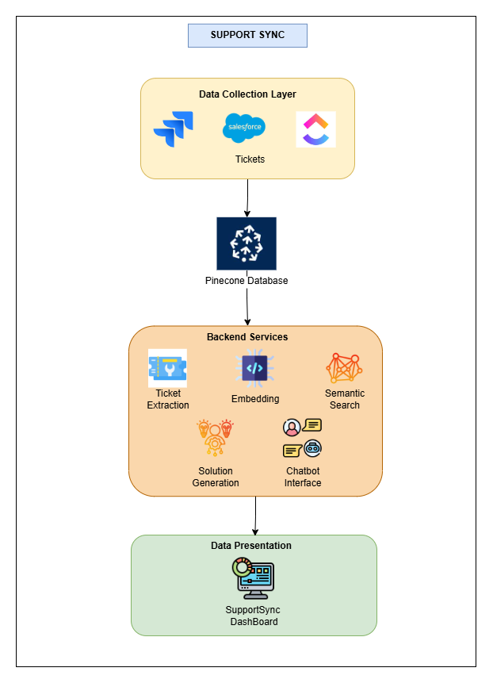

Figure 1: Architecture Diagram

The SupportSync architecture is designed to simplify issue resolution for IT teams through integrated systems and AI-powered support. At its core, the User Interface Layer enables developers to log in, access, and manage tickets directly. The Authentication Layer secures access with Auth0, restricting platform use to authorized users only. An Integration Layer connects SupportSync with ticketing systems like JIRA and ServiceNow to pull and store DONE tickets. These resolved tickets are embedded as vectors within the Data Storage Layer using Pinecone, allowing for quick searches to find relevant past solutions. The AI Solution Engine leverages OpenAI embeddings and an LLM model to generate solution recommendations based on similar tickets. An LLM-powered Chatbot further supports users by offering clarification options and document upload features for personalized responses. Finally, the Logging and Monitoring Layer records activity to support system enhancement, creating a streamlined, AI-supported workflow for resolving IT issues efficiently.

The proposed system for SupportSync - AI-Driven Automated Ticket Resolution comprises several interconnected modules designed to streamline ticket resolution by leveraging AI-driven techniques and semantic search:

1. Ticket Extraction Module: The Ticket Extraction Module interfaces with the organization's ticketing platform, supporting tools such as Jira, ClickUp, and Salesforce. By using an API token, the system retrieves tickets in three key statuses: TODO, IN PROGRESS, and DONE/CLOSED. "DONE" or "CLOSED" tickets are pivotal as they provide resolutions to past issues, which form the foundation of the knowledge base for future problem-solving. This module normalizes data to ensure consistency across varying ticket platform APIs.
2. Embedding Module: The Embedding Module converts textual ticket data into vector representations for efficient similarity searches. Using OpenAI’s embedding algorithm (OpenAI Embedding), it transforms the content of DONE/CLOSED tickets into numerical vectors. These vectors capture the core issues and resolutions, facilitating accurate comparisons and retrievals. The embeddings are stored in Pinecone Vector Database, allowing for efficient semantic searches across large datasets. The module optimizes embedding operations to handle large volumes while excluding irrelevant content.
3. Pinecone Vector Storage and Semantic Search Module: The Pinecone Vector Storage and Semantic Search Module is central to the retrieval functionality, utilizing Pinecone as the vector database. The system compares vectors of new tickets with stored vectors of DONE/CLOSED tickets to find similar past issues. The results are ranked based on relevance, providing the most pertinent solutions. Continuous updates and fine-tuning ensure that the search remains accurate as the vector database grows, addressing challenges related to the curse of dimensionality.

Figure 2: System Workflow

1. Solution Generation Module: The Solution Generation Module combines retrieved similar tickets with a Large Language Model (LLM), specifically llama-3.2-90b-text-preview, to generate tailored solutions. This module processes both the new ticket details and relevant historical data to propose solutions that reflect both the general knowledge of the LLM and the contextual understanding from the matching tickets. Though accurate, ongoing evaluation of the LLM ensures continual improvement of solution relevance.
2. Chatbot Interface with Multimedia Support Module: The Chatbot Interface Module enhances user interaction by offering conversational support. If the initial solution is insufficient, the chatbot provides additional context and allows for multimedia file uploads, such as PDFs. The system integrates content from uploaded multimedia files into the vector database, enriching the knowledge base. The chatbot, powered by llama-3.2-90b-text-preview, leverages this expanded data to offer personalized, context-sensitive responses, further improving user engagement and issue resolution. Challenges include accurately processing multimedia content and ensuring relevance in responses.

Algorithm:

* + - 1. *Start*
      2. *Login to system*
      3. *The system connects to the ticketing platform (Jira, ClickUp, Salesforce) using an API token.*
      4. *The system authenticates the API.*
      5. *Endless Loop:*
         1. *The system retrieves tickets with statuses, extracting relevant data such as ticket ID, description, comments, and additional notes.*
         2. *The extracted ticket data is processed by the embedding module.*
         3. *The embeddings are stored in the Pinecone vector database for efficient retrieval.*
         4. *New ticket data is converted into a vector and queried against Pinecone for similar DONE/CLOSED tickets.*
         5. *The new ticket data and matched tickets are input into the LLM to generate a solution.*
         6. *User can query the chatbot for more details or upload multimedia files (e.g., PDFs).*
      6. *Logout*
      7. *Stop*

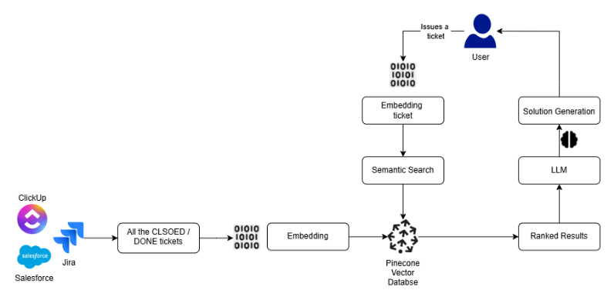

The system is a streamlined process that connects multiple modules to provide quick and relevant solutions to IT issues. It starts by securely connecting to a ticketing platform (e.g., Jira) via API to retrieve DONE/CLOSED tickets, which are then embedded into vector format and stored in the Pinecone Vector Database. When a new ticket is raised, it is embedded and searched for similar tickets in Pinecone. The top matches are used to generate a solution through the llama-3.2-90b-text-preview model. If further assistance is needed, a chatbot powered by the same LLM provides conversational support and handles multimedia files for more personalized responses. Each module works together, using shared access to the Pinecone database, to deliver efficient and intelligent issue resolution.

In conclusion, the integration and workflow of this system ensure that developers can rely on an organized, responsive, and intelligent solution-generation pipeline. By embedding best practices in data processing, vector storage, and LLM-based generation, the system enables IT professionals to solve issues faster and more effectively, driving overall productivity and reducing redundancy.

1. RESULTS AND DISCUSSIONS

To illustrate the functionality and effectiveness of SupportSync, we present a series of screenshots highlighting its key modules and workflow. The user interface is thoughtfully designed to optimize the user experience and streamline IT support processes. It includes a secure login screen, an intuitive dashboard for managing tickets, and detailed ticket views for in-depth issue analysis. Additionally, the platform features a semantic search interface that allows users to retrieve contextually relevant solutions quickly and efficiently. A chatbot interface is also integrated to provide automated assistance, further enhancing support capabilities. Each interface element is carefully designed to ensure simplicity, accessibility, and efficiency, empowering IT professionals to manage and resolve tickets effectively. These features work together to make SupportSync a user-friendly and powerful tool for improving IT support workflows.

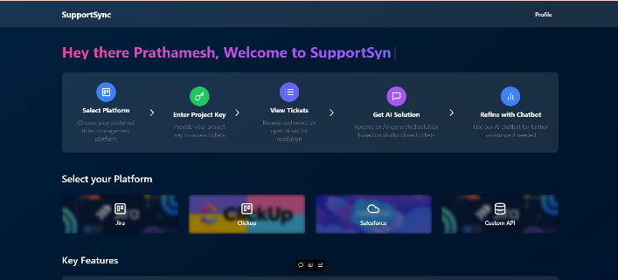

Figure 3 Dashboard

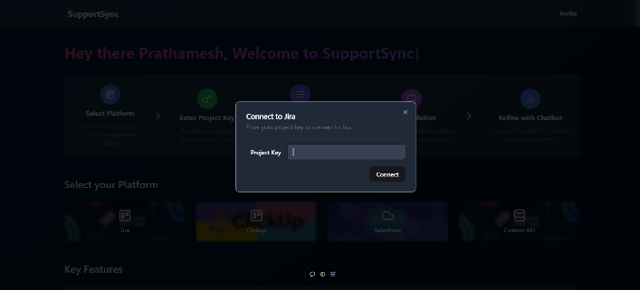

Figure 5 Specifying project name

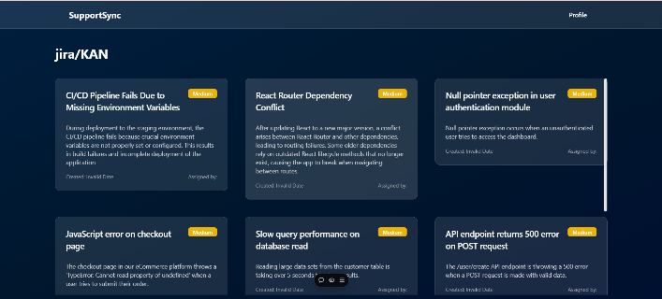

Figure 6 Tickets Dashboard

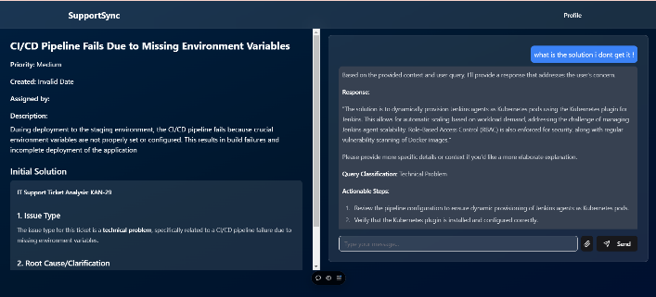

Figure 7 Ticket Output and Chatbot

The screenshots also highlight the seamless integration of the chatbot interface, showing how users can interact with the system, receive context-aware responses, and upload multimedia files for additional support. These visuals offer a clear representation of SupportSync’s automated process and its user-friendly interface, underscoring its efficiency and adaptability in real-world support environments.

The SupportSync system uses the LLaMA 3.2 model with 90 billion parameters, an advanced version of previous LLaMA models, such as the 65-billion parameter version. LLaMA 65B has already shown strong performance in tasks like reasoning, comprehension, and multitasking, even surpassing well-known models like GPT-3 in several benchmarks. This highlights its capability to handle complex tasks with high accuracy of 68.6% average. Increasing parameters by 35B more parameter would increase the accuracy by 5% to 15% in every benchmarks.[15]

By integrating the LLaMA 3.2 model with 90 billion parameters, SupportSync benefits from enhanced contextual understanding and improved ability to generate relevant solutions. Although specific studies on LLaMA 90B are limited, its larger size and improved architecture are expected to deliver better results, such as faster ticket resolution and more accurate recommendations. Future work will focus on evaluating its real-world performance to ensure reliability and scalability.

1. CONCLUSION

In conclusion, SupportSync revolutionizes traditional ticketing systems by integrating AI-driven automation to streamline the issue resolution process and enhance overall efficiency. By seamlessly integrating with widely used platforms such as JIRA and ServiceNow, the system enables faster, smarter ticket management. The project focuses on reducing manual efforts, improving response times, and empowering IT professionals to resolve issues more efficiently. Through the use of AI language models, vector databases, and a multimedia-supporting chatbot, SupportSync optimizes every aspect of the support workflow, ensuring rapid and accurate solutions.

The implementation of AI technologies within SupportSync has demonstrated substantial improvements in ticket response time, solution accuracy, and user satisfaction. By analyzing historical ticket data, the system generates context-aware responses, significantly improving productivity and user experience. Additionally, SupportSync’s scalability and adaptability make it suitable for a wide range of ticketing platforms and organizational sizes. As businesses grow and their support requirements evolve, the platform can easily scale to handle an increasing volume of tickets and integrate new features or platforms. This flexibility positions SupportSync as a powerful and versatile tool for support teams across industries, allowing them to resolve issues more efficiently while accommodating shifting workflows and technological advancements.

Ultimately, SupportSync aims to transform support operations by providing AI-powered tools that streamline ticket management, reduce response times, and deliver precise, context-aware solutions, ultimately improving both productivity and user satisfaction.

REFERENCES

1. Qamili, Ruanda, Shaban Shabani, and Johannes Schneider. "An intelligent framework for issue ticketing system based on machine learning." *2018 IEEE 22nd International Enterprise Distributed Object Computing Workshop (EDOCW)*. IEEE, 2018.
2. Fuchs, Simon, Clemens Drieschner, and Holger Wittges. "Improving support ticket systems using machine learning: A literature review." (2022).
3. Truss, Mario, and Stephan Boehm. "AI-based Classification of Customer Support Tickets: State of the Art and Implementation with Auto ML." *arXivpreprintarXiv:2406.01789* (2024).
4. Zangari, Alessandro, et al. "Ticket automation: An insight into current research with applications to multi-level classification scenarios." *Expert Systems with Applications* 225 (2023): 119984.
5. Pan, James Jie, Jianguo Wang, and Guoliang Li. "Survey of vector database management systems." *The VLDB Journal* 33.5 (2024) - Springer: 1591-1615.
6. Guan, Yanchu, et al. "Intelligent virtual assistants with llm-based process automation." *arXiv preprint arXiv:2312.06677* (2023).
7. Suresh, Sujay. How can a company enhance employee satisfaction and time effectiveness by enabling AI in their ticketing system? Diss. Dublin, National College of Ireland, 2022.
8. S. Agarwal, V. Aggarwal, A. R. Akula, G. B. Dasgupta, and G. Sridhara. "Automatic problem extraction and analysis from unstructured text in IT tickets." IBM Journal of Research and Development, 2017.
9. Kale, Satyanand. (2024). From Text to Recommendations: How Vector Databases are Revolutionizing Personalized Content Delivery. International Journal for Research in Applied Science and Engineering Technology. 12. 3376-3387. 10.22214/ijraset.2024.59852.
10. Wahba, Yasmen, Nazim H. Madhavji, and John Steinbacher. Evaluating the effectiveness of static word embeddings on the classification of IT support tickets. Proc. of 30th Int. Conf. on CS and SE, 2020.
11. Arici, Nicola, et al. LLM-based Approaches for Automatic Ticket Assignment: A Real-world Italian Application. NL4AI@ AI IA*, 2023.
12. Revina, Aleksandra, Krisztian Buza, and Vera G. Meister. IT ticket classification: The simpler, the better. IEEE Access 8 (2020): 193380-193395.
13. Sanodia, Geetesh, and Premkumar Ganesan. Optimizing IT Operations Through AI - A Comprehensive Framework. Journal of Computer Engineering and Technology 6(1), 2023.
14. Alexander, T. Proactive Customer Support: Re-Architecting a Customer Support/Relationship Management Software System Leveraging Predictive Analysis/AI and Machine Learning. Engineering: Open Access 2.1 (2024): 39-50.
15. Dubey, Abhimanyu, et al. "The llama 3 herd of models." *arXiv preprint arXiv:2407.21783* (2024).